**Ehsas-Hub**

|  |
| --- |
|  |

**By:**

**Zain Muneer**

**35937**

**Abdullah shahid**

**35438**

**Hamza Ahmed**

**31967**

**Supervised by:**

**Tajamul Shahzad**

**Faculty of Computing**

**Riphah International University, Islamabad**

**Fall 2024**

**A Dissertation Submitted To**

**Faculty of Computing,**

**Riphah International University, Islamabad**

**As a Partial Fulfillment of the Requirement for the Award of the Degree of**

**Bachelors of Science in Computer Science**

**Faculty of Computing**

**Riphah International University, Islamabad**

Date: December, 2024

**Final Approval**

This is to certify that we have read the report submitted by ***Zain Muneer 35937 Abdullah Shahid 35438 Hamza Ahmed 31967*** for the partial fulfillment of the requirements for the degree of the Bachelors of Science in Computer Science (BSCS). It is our judgment that this report is of sufficient standard to warrant its acceptance by Riphah International University, Islamabad for the degree of Bachelors of Science in Computer Science (BSCS).

**Committee:**

|  |  |
| --- | --- |
| **1** | Tajamul Shahzad  (Supervisor) |
|  |  |
| **2** | Dr. Musharraf Ahmed  (Head of Department) |

**Declaration**

We hereby declare that this document “**Ehsas hub**” neither as a whole nor as a part has been copied out from any source. It is further declared that we have done this project with the accompanied report entirely on the basis of our personal efforts, under the proficient guidance of our teachers, especially our supervisor **Tajumal Shahzad,** if any part of the system is proved to be copied out from any source or found to be reproduction of any project from anywhere else, we shall stand by the consequences.

**___________________________**

**Zain Muneer**

**35937**

**___________________________**

**Abdullah Shahid**

**35438**

**___________________________**

**Hamza Ahmed**

**31967**

**Dedication**

Our project is dedicated to our parents, seniors, friends, and our supervisor "**Tajamul Shahzad**" who has been our continual source of inspiration and whose support has helped this project succeed. This project would not have been possible without their love and support.

**Acknowledgement**

First of all, we are obliged to Allah Almighty the Merciful, the Beneficent and the source of all Knowledge, for granting us the courage and knowledge to complete this Project.

We are deeply grateful to our friends who helped us along the way, our families for their support, and our supervisor, **Tajamul Shahzad**, for his direction.

**___________________________**

**Zain Muneer**

**35937**

**___________________________**

**Abdullah Shahid**

**35438**

**___________________________**

**Hamza Ahmed**

**31967**

**Abstract**

Ehsas Hub is a community-driven platform to connect donors, students, and volunteers toward a common cause: that is, making education accessible to the needy. Unlike most platforms focusing on money, Ehsas Hub is more interested in book-sharing. By doing this, it pairs each donated book with a student who actually needs the book on what they are interested in and what they aim to do in the future. Ehsas Hub, through smart technology, makes book recommendations to each learner to learn and grow, system takes student interest like (Favorite book, author, genres) and provide top rated books. It ensures that all that is done is open and honest so that trust may be built. This doesn't only get the right resources to the right students but empowers them to reach their full potential.

Table of Contents

Table of Contents i

List of Tables iv

List of Figures v

Chapter 1: Introduction 7

1.1 Goals and Objectives 7

1.1.1 Goals: 7

1.1.2 Objectives: 7

1.2 Scope of the Project 8

1.3 Functional Features: 8

1.4 Conclusion: 8

Chapter 2: Literature Review 10

2.1 Introduction 10

2.2 Background and Problem Elaboration 10

2.3 Detailed Literature Review 10

2.3.1 Definitions 10

2.3.2 Related Research Work 1 11

2.3.3 Related Research Work 2 11

2.4 Literature Review Summary Table 11

2.5 Research Gap 11

2.6 Problem Statement 12

2.7 Conclusion 12

Chapter 3: Requirements and Design 14

3.1 Requirements 14

3.1.1 Functional Requirements 14

3.1.2 Non-Functional Requirements 18

3.1.3 Hardware and Software Requirements 18

3.2 Proposed Methodology 19

3.3 System Architecture 20

3.4 Use Cases 21

3.4.1 Sign Up: 26

3.4.2 Login: 26

3.4.3 Recover password: 27

3.4.4 Edit Profile: 27

3.4.5 Donate Books: 27

3.4.6 Request Book: 28

3.4.7 Manage Donor Request: 28

3.4.8 Manage Account: 29

3.4.9 Manage Listing: 29

3.4.10 Feedback: 29

3.4.11 Recommended Books: 30

3.4.12 Add to Favorites: 30

3.4.13 Requested Book Statistics: 31

3.4.14 Search Book: 31

3.4.15 Donated Book Statistics: 31

3.4.16 Manage Request: 32

3.4.17 Logout: 32

3.4.18 View Recommended Books: 32

3.4.19 See book status: 33

3.5 Entity Relationship diagram 35

3.6 Activity Diagram 36

3.7 GUI Graphical User Interfaces (*Optional)* 36

Chapter 4: Implementation and Test Cases 38

4.1 Implementation 38

4.1.1 Implementation Overview 38

4.1.2 Introduction 38

4.1.3 Prototype 38

4.1.4 Key Implementation Components 39

4.2 Test Cases 41

4.2.1 Admin Test Cases 41

4.2.2 User (Needy) Test Case 41

4.2.3 Volunteer Test Case 42

4.2.4 Donor Test Case 43

4.3 Test Metrics 44

4.3.1 Common Attributes of Test Case Metrics 44

4.3.2 Test Summary Table 45

4.4 Conclusion 45

Chapter 5: Experimental Results and Analysis 47

5.1 Introduction 47

5.2 Experimental Setup 47

5.2.1 Platform Performance Evaluation 47

5.2.2 Recommendation System Effectiveness 49

5.2.3 Authentication and Security 50

5.3 Conclusion 51

Chapter 6: Conclusion and Future Directions 53

6.1 Introduction 53

6.2 Achievements and Improvements 53

6.2.1 Front-End Achievements: 53

6.2.2 Backend Achievement’s 53

6.2.3 Recommendation Engine: 54

6.2.4 Database Enhancements: 54

6.3 Critical Review 54

6.3.1 Strengths 54

6.3.2 Weaknesses: 54

6.4 Future Recommendations 55

6.4.1 Enhancements to Current Modules: 55

6.4.2 Additional Features: 55

6.4.3 Future Specific Work Plan: 55

6.5 Conclusion 55

References 56

Appendix 57

Appendix A: Guidelines 57

Appendix B: Heading of Sample Appendix B 57

Formatting Guidelines 58

Chapter 1: Heading 1 58

1.1 Heading 2 58

1.1.1 Heading 3 58

Tables and Figures 59

Equations 60

Header/Footer 60

Other Formatting Guidelines 61

References 61

List of Tables

Table 2.1: This is Sample table caption 10

Table 3.1: This is Sample table caption 13

Table 3.2: This is Sample table caption

Table 3.3:

Table 3.4

List of Figures

Figure 1: List of Styles 46

Figure 2: IEEE Reference style 47

Chapter 01:

Introduction

# Introduction

Many students today who don't have much money and access to basic learning materials like books, which are important for both learning and personal growth. On the other hand, many people and groups are ready to donate books but don't know how to get in touch with people who need them. Ehsas Hub, a digital platform that makes it easy for donors, students, and volunteers to meet, can fill this gap. The main goal of this project is to make it easier for people to donate books and make sure that they get to the right people by using a personalized recommendation system that is based on academic interests, and preferences.

Ehsas Hub is more than just a place to donate; it's a step towards making education available to everyone. The platform improves the process of matching given books with people who can use them by adding a recommendation system. This way, every book donated has the chance to improve someone's education. The platform uses technology to get around the problems that come with traditional book donation methods, like matching people with the right books.

## Goals and Objectives

### Goals:

1. Bridge the Gap Between Donors and Needy:
2. Empower Volunteer Coordination:
3. Promote Transparency and Reliability:
4. Leverage Technology for Social Good:

### Objectives:

1. Develop a Comprehensive Donation and Volunteer Management System:
2. Provide Intelligent Recommendations for Book Donations:
3. Streamline Volunteer Engagement and Task Management:
4. Ensure Platform Adaptability and User-Centric Growth:

## Scope of the Project

* **Students:** Students from low-income families, who live in orphanages or underprivileged areas for their studies, need educational materials.
* **Donors:** People or groups eager to contribute books for the good of the community.
* **Volunteers:** Those who want to help with logistics, such picking up and distributing books, in order to support the cause.

## Functional Features:

* **User Registration and Authentication:** encompass secure login, multi-factor authentication, and the definition of user roles, including student, donor, and volunteer.
* **Profile Management:** Customizable profiles for students (academic interests), donors (donation listings), and volunteers (availability and locations) are provided.
* **Recommendation System:** Proposes books, articles, and novels aligned with students’ academic interests and the highest-rated books and authors.
* **Donation management enables the facilitation of book donations**: Offering options for categorization and presentation in a searchable catalog.
* **Request System:** Facilitates the process for students and institutions to request particular books or genres, aligned with available donations.

## Conclusion:

With the use of technology, Ehsas-Hub hopes to improve book donations by boosting efficiency, equity, and personalization. The idea aims to provide a smart and organized platform so that no student will be denied the opportunity to learn because they cannot afford books.

**Chapter 02:   
Literature Review**

# Literature Review

## Introduction

In many areas, like e-commerce, entertainment, and education, recommendation systems are an important part of giving each user a personalized experience. This literature review is mostly about book recommendation systems, which try to match users with good books based on their likes, dislikes, and past actions. This chapter goes into definitions, linked research, and an analysis of methodologies. It then looks for research gaps and comes up with the Ehsas=Hub project's problem statement with an emphasis on book recommendation platforms; this chapter provides a thorough analysis of recommendation systems. It examines fundamental ideas, current studies, approaches used in comparable systems, and highlights important gaps pertinent to the Ehsas-Hub project.

## Background and Problem Elaboration

Book recommendation systems have evolved from simple content-based methods to sophisticated hybrid approaches. The challenges addressed by these systems include handling vast datasets, improving recommendation accuracy, and overcoming issues like cold-start problems and sparsity in user feedback. For Ehsas Hub, the aim is to integrate a recommendation engine specifically tailored to students' interests and academic goals, leveraging techniques like collaborative filtering and machine learning.2.3 Detailed Literature Review

## Detailed Literature Review

### Definitions

* **Content-Based Filtering**: Recommends items similar to those the user has liked based on item attributes (e.g., genre, author).
* **Collaborative Filtering**: Makes recommendations by finding similarities among users or items based on user ratings or interactions.
* **Hybrid Systems**: Combines content-based and collaborative methods to overcome the limitations of each technique.

### Related Research Work 1

A study by Gupta et al. (2020) explores the effectiveness of recommendation systems in e-commerce and library platforms. The research highlights the utility of content-based filtering for user-specific recommendations and discusses its limitation in handling new users (cold-start problem). Collaborative filtering, though powerful, requires extensive datasets to deliver accurate predictions.

### Related Research Work 2

A personalized book recommendation system developed by Sarma et al. (2021) combines clustering techniques with cosine similarity to recommend books. The study uses datasets from Goodreads and applies machine learning models to improve recommendation accuracy. It effectively addresses sparsity and cold-start problems through clustering methods**​.**

## Literature Review Summary Table

Table 1.1: This is Sample table caption

|  |  |  |  |  |  |  |  |
| --- | --- | --- | --- | --- | --- | --- | --- |
| Study | |  | | --- | |  |  |  | | --- | | Methodology | | Strengths | |  | | --- | |  |  |  | | --- | | Limitations | |
| Gupta et al. (2020) | Content-Based Filtering | Personalized recommendations | Struggles with cold-start problems |
| Sarma et al. (2021) | Clustering + Collaborative Filtering | |  | | --- | |  |  |  | | --- | | High accuracy and handles sparsity well | | Requires well-curated datasets |
| Rajpurkar et al. (2015) | Hybrid (Content + Collaborative) | Improves recommendation relevance | Computationally intensive for large datasets |

## Research Gap

Existing systems largely focus on generic book recommendations and often fail to align with specific user goals, such as academic interests. Moreover, while hybrid systems improve accuracy, they introduce higher computational complexity. There is a lack of scalable solutions tailored to nonprofit platforms like Ehsas Hub, which serve diverse user bases including students and donors.

## Problem Statement

The challenge is to design a scalable and efficient book recommendation system for Ehsas Hub that:

1. Personalizes recommendations based on user interests, academic goals, and ratings.
2. Effectively addresses cold-start problems and data sparsity.
3. Operates within the constraints of a nonprofit organization serving varied stakeholders.

## Conclusion

In conclusion, while numerous techniques exist for book recommendations, few are tailored for socially-driven platforms. The findings of this review validate the need for a hybrid, efficient, and student-centered system as proposed in Ehsas Hub

**Chapter 03:**

**Requirements and Design**

# Requirements and Design

In this chapter, we have developed our functional requirements for our actors i.e. (**Needy**, **Donor, Admin** and **Volunteer**). The requirements are designed for especially for Ehsas-Hub platform.

**Ehsas-Hub** is a web-based platform designed to connect or interact with Needy and Donors easily with each other with help of volunteer.

The platform is user-friendly, easy to navigate and search, and provide a convenient and efficient way for both parties to connect and interact with each other.

We created our system **use cases** against each functional requirement and created use case diagrams, fully dressed use cases for our actors i.e. (User, Admin, Donor and Volunteer).

## Requirements

### Functional Requirements

**Needy:**

Table 3.1: This is Sample table caption

|  |  |
| --- | --- |
| ID | Requirements |
| FR-1.1 | User shall be able to Sign Up. |
| FR-1.2 | User shall be able to login to their account. |
| FR-1.3 | User shall be able to Forget/Recover their password. |
| FR-1.4 | . |
| FR-1.5 | User shall be able to view profile |
| FR-1.6 | |  | | --- | | User shall be able to edit/update their profile. |  |  | | --- | |  | |
| FR-1.7 | |  | | --- | |  |   User shall be able to View Books Based on Recommendation with respect to their interest. |
| FR-1.8 | User shall be able to request specific books. |
| FR-1.9 | |  |  | | --- | --- | | User shall be able to add book to favourite | . |  |  | | --- | |  | |
| FR-1.10 | User shall be able to See favourite books. |
| FR-1.11 | User shall be able to view book stats. |
| FR-1.12 | User shall be able to view requested books list. |
| FR-1.13 | User shall be able to search books. |
| FR-1.14 | User shall be able to give feedback. |
| FR-1.15 | User shall be able to Logout |

**Donor:**

Table 3.2: This is Sample table caption

|  |  |
| --- | --- |
| ID | Requirements |
| FR-2.1 | |  | | --- | | Donor shall be able to Sign Up. |  |  | | --- | |  | |
| FR-2.2 | Donor shall be able to Login. |
| FR-2.3 | Donor shall be able to forget/recover their Password. |
| FR-2.4 | Donor shall be to view profile. |
| FR-2.5 | Donor shall be able to edit profile. |
| FR-2.6 | Donor shall be able to donate books. |
| FR-2.7 | |  | | --- | |  |  |  | | --- | |  |   Donor shall be able to view donated book stats. |
| FR-2.8 | |  | | --- | | Donor shall be able to view donated book list. |  |  | | --- | |  | |
| FR-2.9 | Donor shall be able to give feedback. |
| FR-2.10 | Donor shall be able to Logout. |

**Volunteer:**

Table 2.3:

|  |  |
| --- | --- |
| ID | Requirements |
| FR-3.1 | Volunteer shall be able to sign up. |
| FR-3.2 | Volunteer shall be able to log in. |
| FR-3.3 | |  | | --- | | Volunteer shall be able to forget/recover password. |  |  | | --- | |  | |
| FR-3.4 | |  | | --- | | Volunteer shall be able to view profile. |  |  | | --- | |  | |
| FR-3.5 | Volunteer shall be able to edit profile. |
| FR-3.6 | Volunteer shall be able to check new request. |
| FR-3.7 | Volunteer shall be able to accept request. |
| FR-3.8 | Volunteer shall be able to check request in process. |
| FR-3.9 | Volunteer shall be able to view completed request. |
| FR-3.10 | Volunteer shall be able to logout. |

**Admin:**

Table 3.4

|  |  |
| --- | --- |
| ID | Requirements |
| FR-4.1 | |  | | --- | | Admin shall be able to sign up. |  |  | | --- | |  | |
| FR-4.2 | |  |  | | --- | --- | | Admin shall be able to login. |  |  |  | | --- | |  | |
| FR-4.3 | |  | | --- | | Admin shall be able to forget/recover password. |  |  | | --- | |  | |
| FR-4.4 | |  | | --- | | Admin shall be able to view profile. |  |  | | --- | |  | |
| FR-4.5 | |  | | --- | | Admin shall be able to edit profile. |  |  | | --- | |  | |
| FR-4.6 | Admin shall be able to manage accounts. |
| FR-4.7 | Admin shall be able to approve account. |
| FR-4.8 | Admin shall be able to reject account. |
| FR-4.9 | Admin shall be able to freeze account. |
| FR-4.10 | Admin shall be able to active account. |
| FR-4.11 | Admin shall be able to view donor request. |
| FR-4.12 | Admin shall be able to accept request. |
| FR-4.13 | Admin shall be able to reject request. |
| FR-4.14 | Admin shall be able to view approved request. |
| FR-4.14 | Admin shall be able to view in process request. |
| FR-4.16 | Admin shall be able to view completed request. |
| FR-4.17 | Admin shall be able to view needy request. |
| FR-4.18 | Admin shall be able to accept needy request. |
| FR-4.19 | Admin shall be able to reject needy request. |
| FR-4.20 | Admin shall be able to view needy approved request. |
| FR-4.21 | Admin shall be able to view needy in process request |
| FR-4.22 | Admin shall be able to view needy completed request. |
| FR-4.23 | Admin shall be able to view volunteer request. |
| FR-4.24 | Admin shall be able to view volunteer approved request. |
| FR-4.25 | Admin shall be able to view volunteer completed request. |
| FR-4.26 | Admin shall be able to view account statistics. |
| FR-4.27 | Admin shall be able to view active list. |
| FR-4.28 | Admin should be able to active book. |
| FR-4.29 | Admin should be able to deactivate book. |
| FR-4.30 | Admin should be able to view feedbacks. |
| FR-4.31 | Admin should be able to log out. |

### Non-Functional Requirements

### Hardware and Software Requirements

**Hardware Requirements:**

**Server**: Dedicated or cloud-based server with at least 16GB RAM and 500GB SSD.

**Storage**: Sufficient storage for books metadata, user data, and logs.

**Processing Power**: Capable of handling concurrent user requests and machine learning tasks.

**Software Requirements:**

**Operating System**: Windows Server.

**Database**: MySQL for storing user profiles, book details, and donation records.

**Frontend**: React.js for building the user interface.

**Backend**: Node.js with Express.js for server-side logic.

**Recommendation System:** Google Collab.

## Proposed Methodology

The project will follow the **agile methodology**, focusing on iterative development and user feedback:

* **Requirement Gathering**: Identify user needs and define functionalities.
* **System Design**: Develop architecture and UI mockups.
* **Development**: Build core modules, including registration, donation management, and recommendation system.
* **Testing**: Validate functionality, performance, and security.

## System Architecture

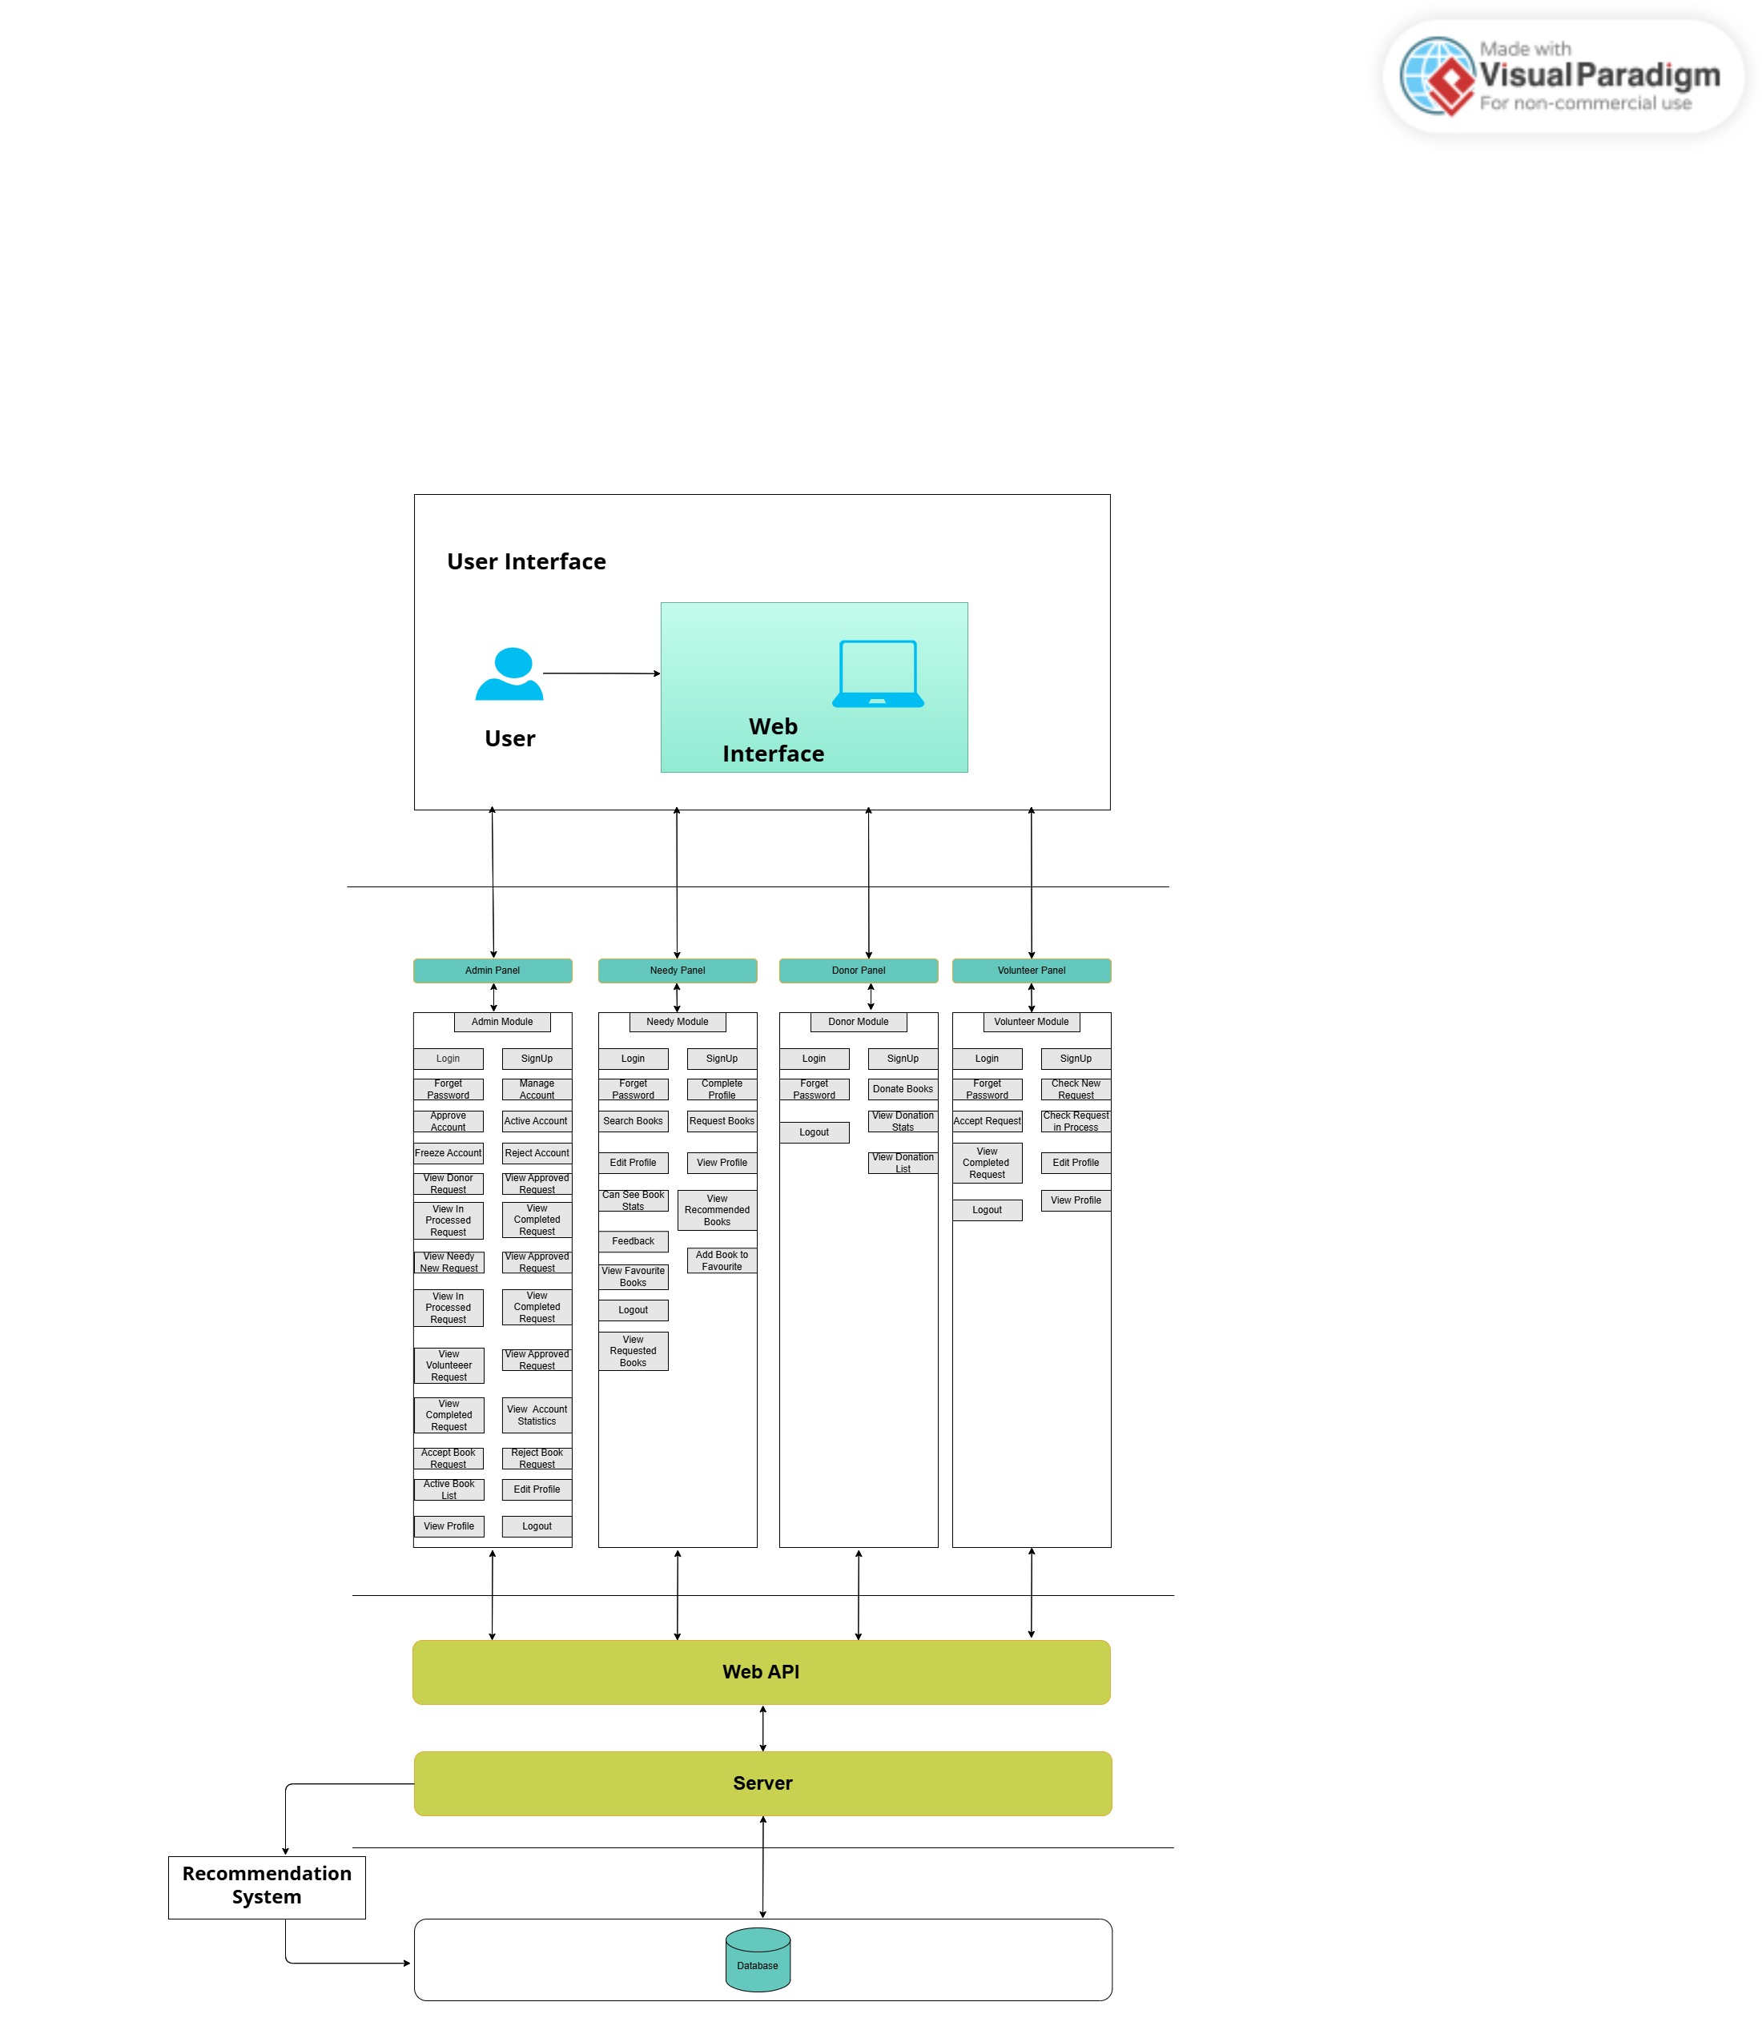

## Use Cases

**Admin Use-Case Diagram:**

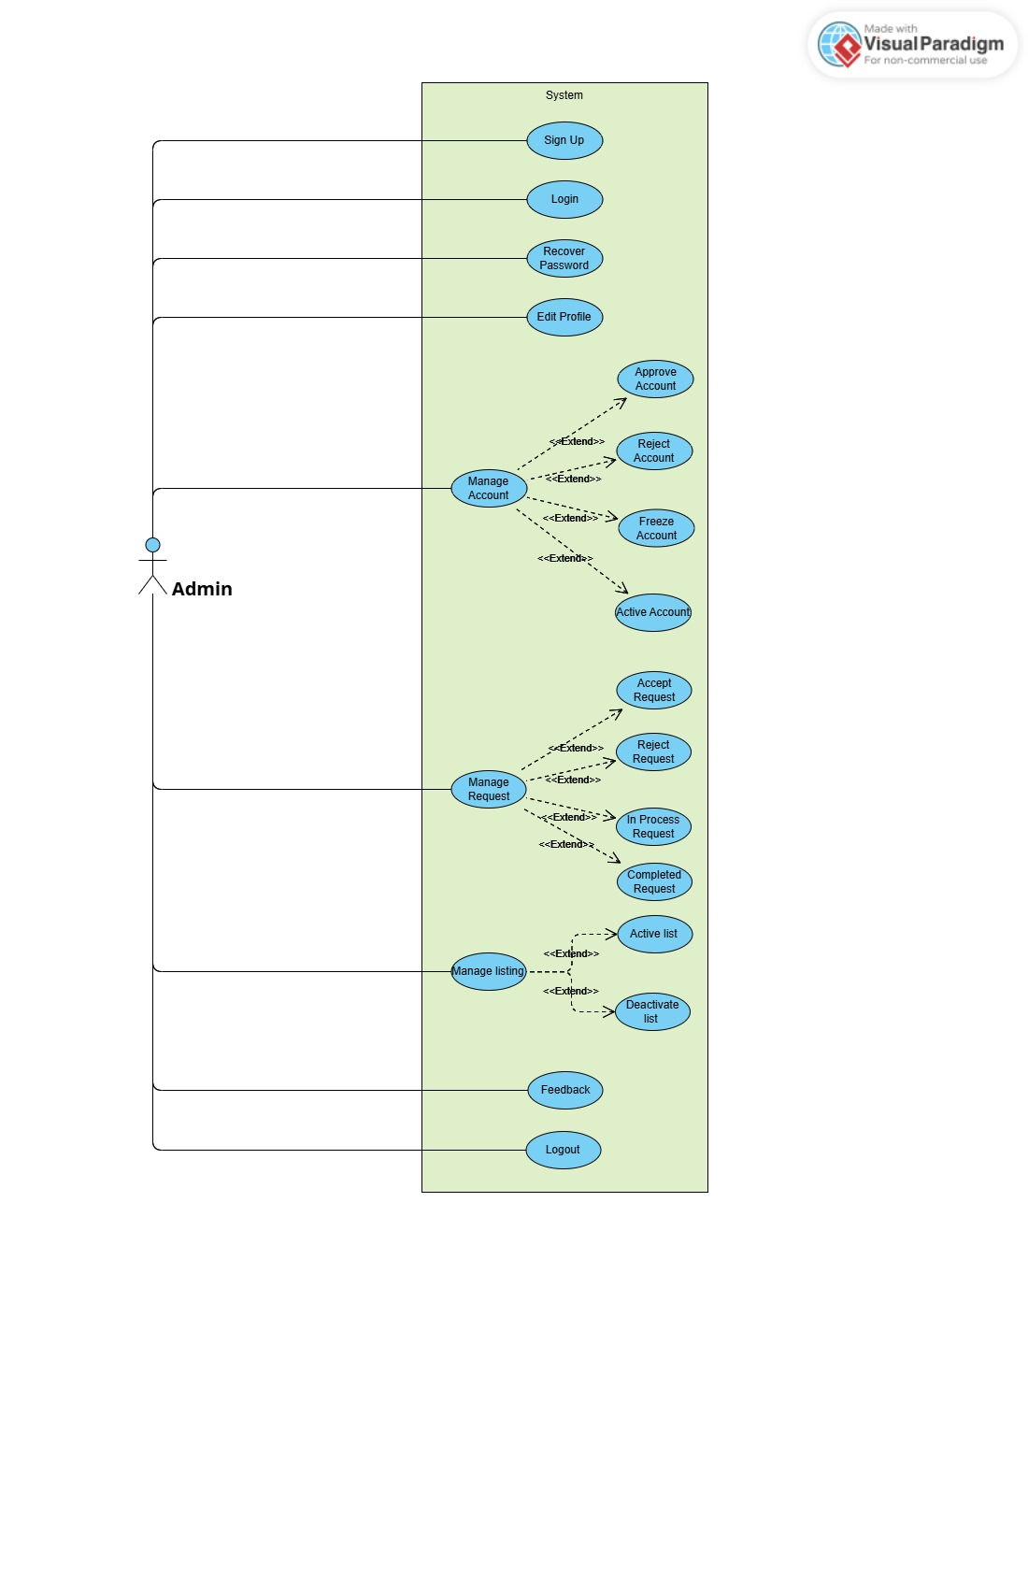

**Needy Use-case Diagram:**

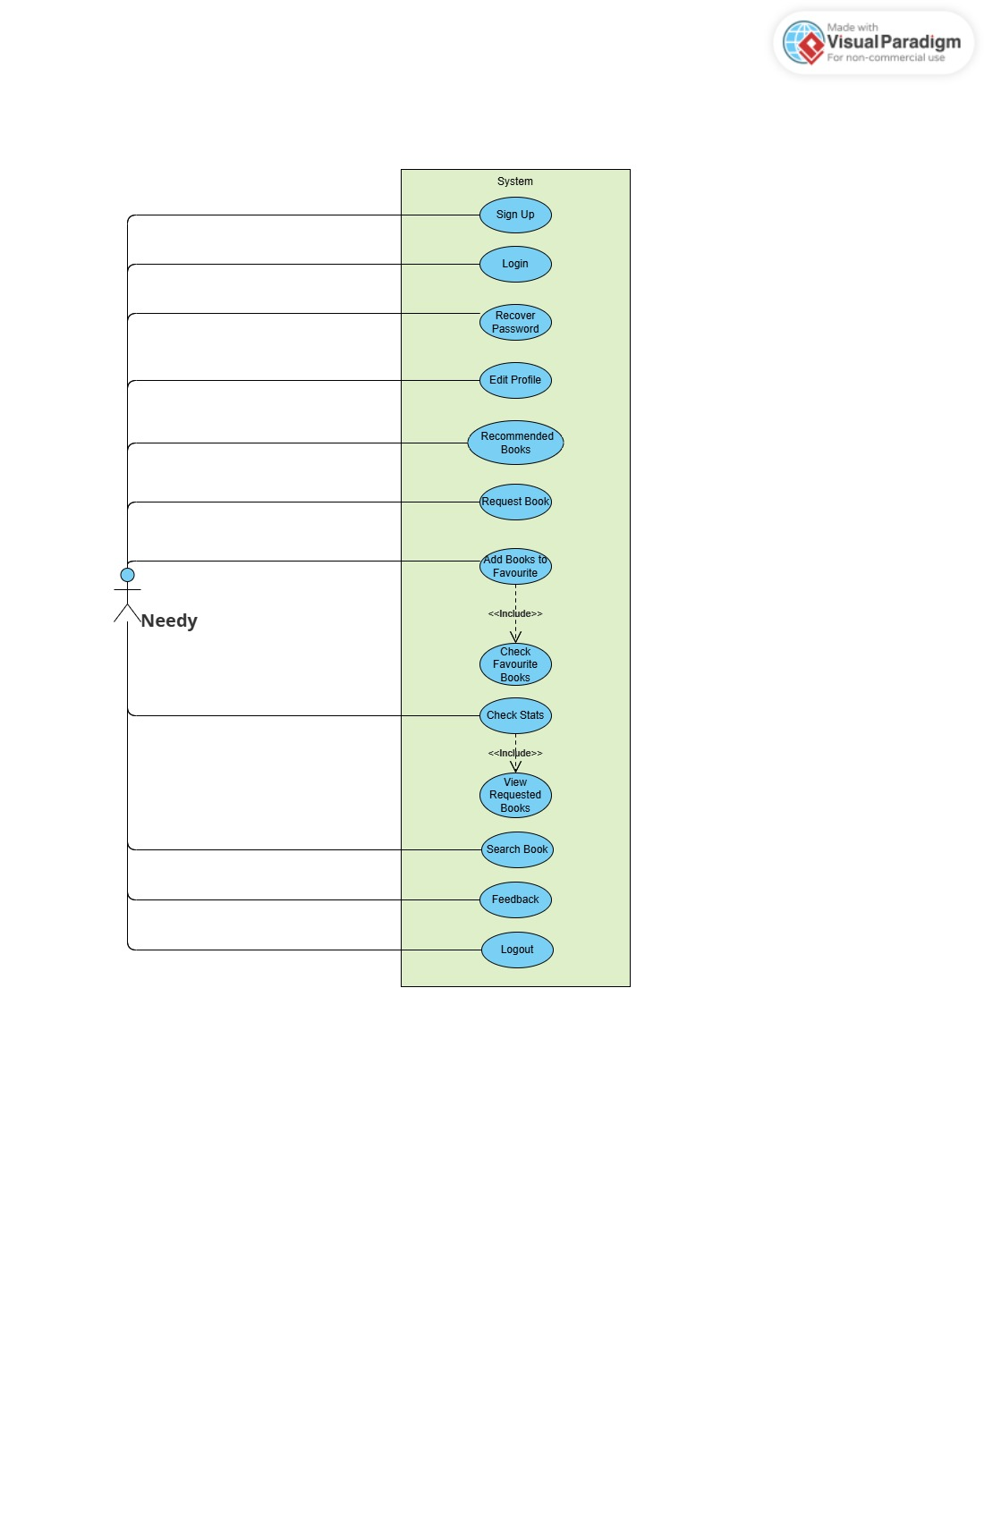

**Donor Use-Case Diagram:**

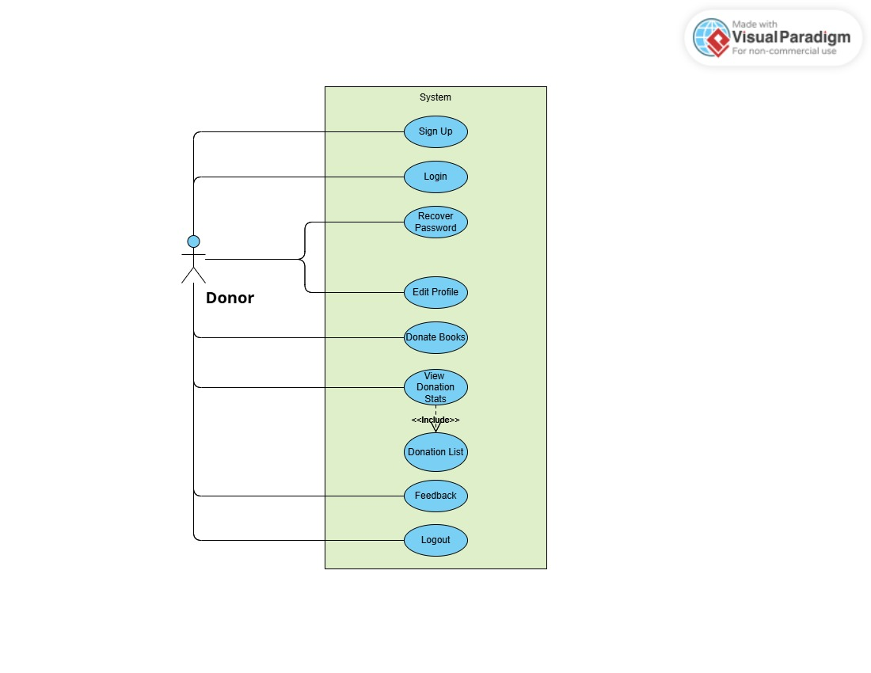

**Volunteer Use-Case Diagram**

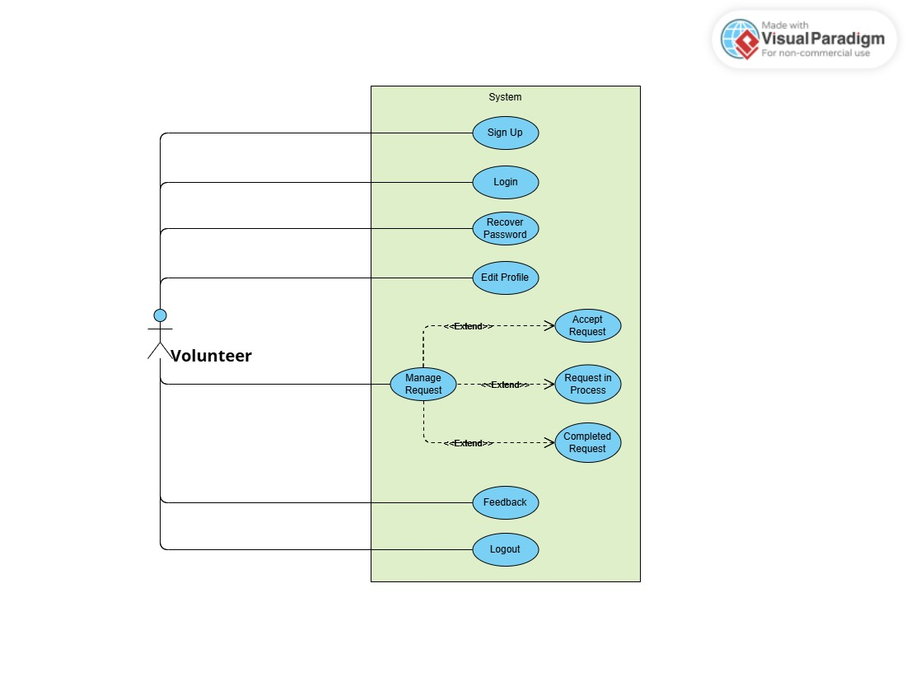

**Full System Use-Case Diagram:**

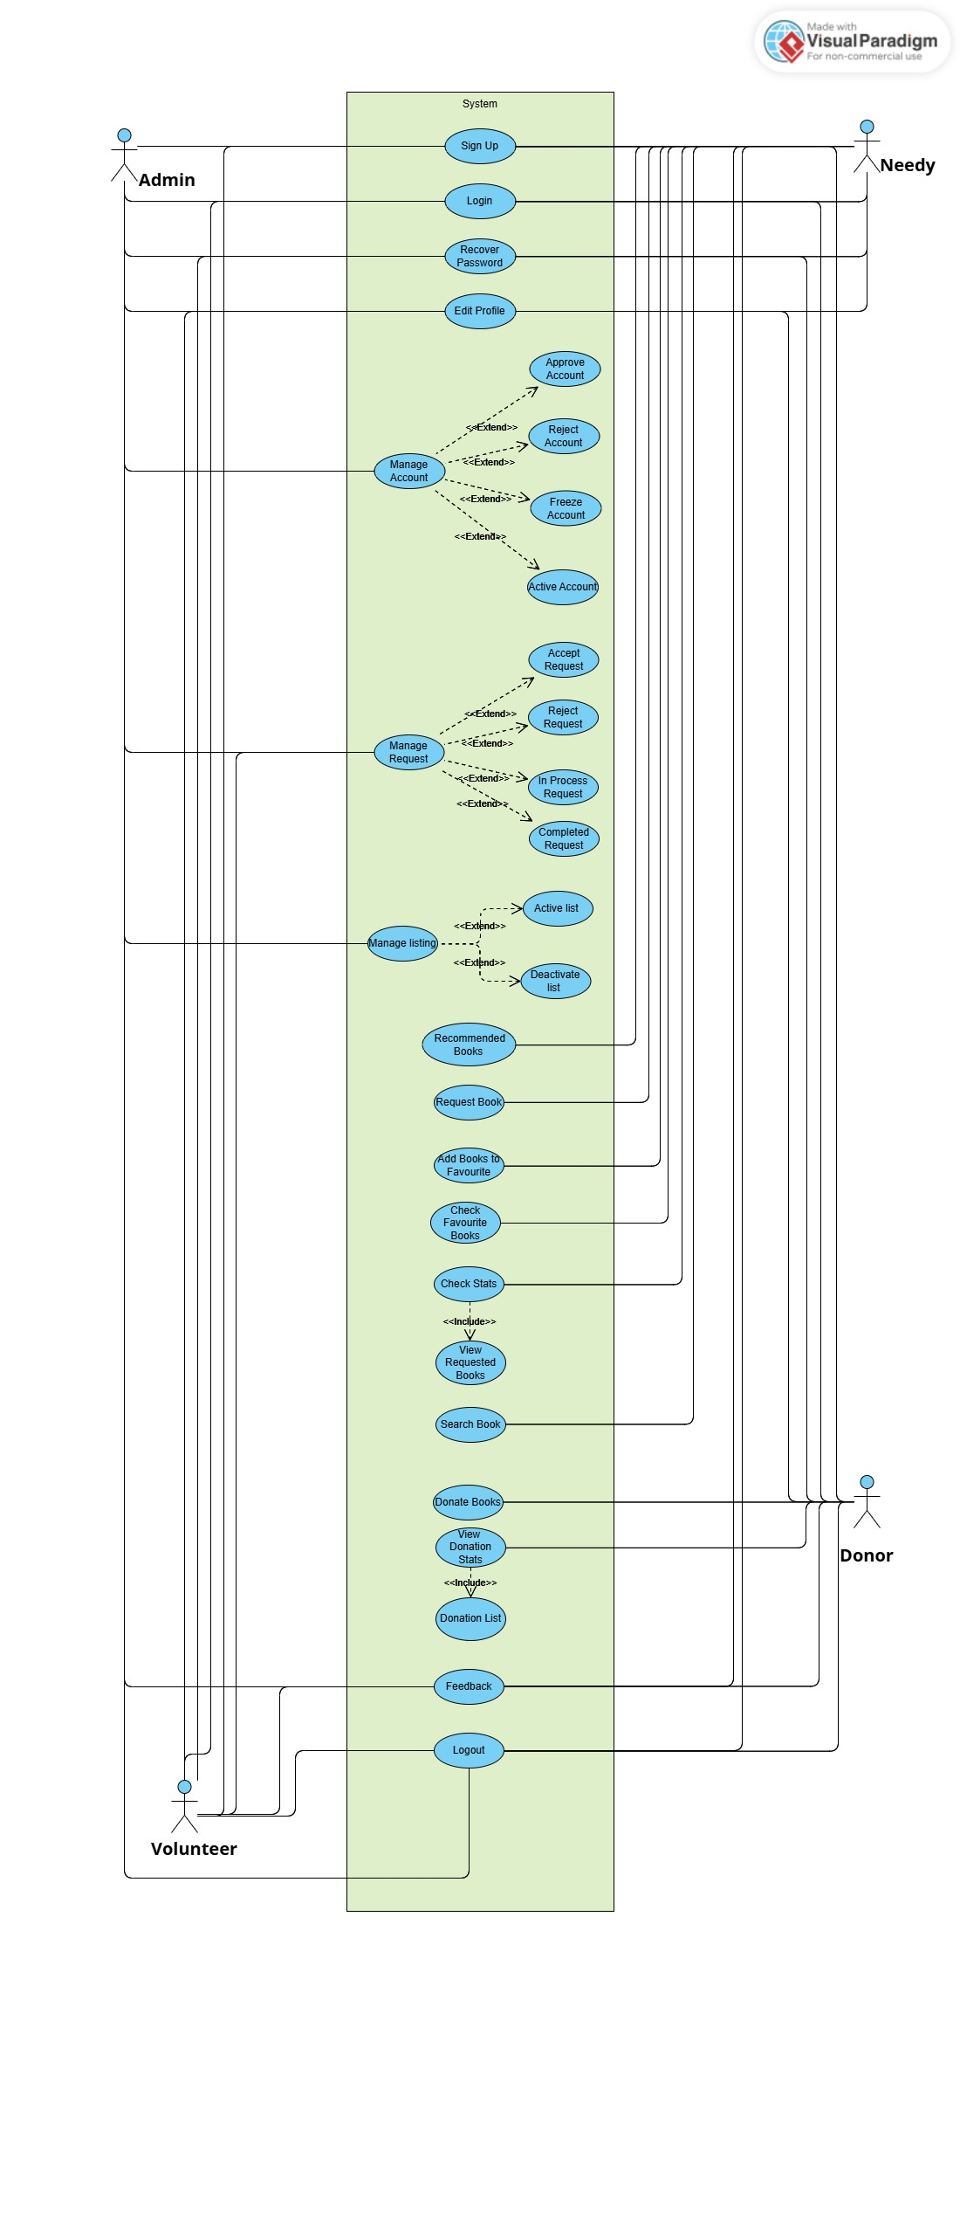

**Fully Dressed Use Cases:**

### Sign Up:

|  |  |
| --- | --- |
| Use CaSE ID | UC-001 |
| uSE CASE NAME | Sign Up |
| Primary Actor | Donor / Needy / Volunteer / Admin |
| Precondition | User is on the registration page |
| Postcondition | User account is successfully created |
| Main Flow | 1. User accesses the Sign Up page  2. Enters required details (name, email, password etc)  3. Clicks Sign Up  4. System validates input  5. System saves data and creates account  6. User is notified of successful registration |
| Alternate Flow | 1a. Missing or invalid data: system prompts correction  1b. Email already exists: system notifies and blocks submission |

### Login:

|  |  |
| --- | --- |
| Use Case ID | UC-002 |
| Use Case Name | Login |
| Primary Actor | Donor / Needy / Volunteer / Admin |
| Precondition | User is registered and on login screen |
| Postcondition | User is logged into the system |
| Main Flow | 1. User enters email and password  2. Clicks Login  3. System verifies credentials  4. Redirects to user dashboard |
| Alternate Flow | 1a. Invalid credentials: system shows error  1b. Account is frozen: system denies access and displays message |

### Recover password:

|  |  |
| --- | --- |
| Use Case ID | UC-003 |
| Use Case Name | Recover Password |
| Primary Actor | Donor / Needy / Volunteer / Admin |
| Precondition | User is on password recovery screen |
| Postcondition | Forgot Password OTP is sent to user’s email |
| Main Flow | 1. User enters registered email  2. Clicks 'Verify Email'  3. System sends OTP via email  4. User resets password via OTP |
| Alternate Flow | 1a. Email not registered: system notifies user |

### Edit Profile:

|  |  |
| --- | --- |
| Use Case ID | UC-004 |
| Use Case Name | Edit Profile |
| Primary Actor | Donor / Needy / Volunteer / Admin |
| Precondition | User is logged in and on profile page |
| Postcondition | Profile is updated |
| Main Flow | 1. User navigates to profile page 2. Edits fields (name, email, Profile picture etc.) 3. Verify email with OTP 4. Clicks Save 5. System updates database 6. Confirms update to user |
| Alternate Flow | 1a. Invalid inputs: system prompts correction |

### Donate Books:

|  |  |
| --- | --- |
| Use Case ID | UC-005 |
| Use Case Name | Donate Books |
| Primary Actor | Donor |
| Precondition | Donor is logged in |
| Postcondition | Book donation is recorded |
| Main Flow | 1. Donor selects 'Switch to donate'  2. Fills form with book details  3. Submits donation  4. System records donation and confirmation by email. |
| Alternate Flow | 1a. Missing book details: system prompts for completion |

### Request Book:

|  |  |
| --- | --- |
| Use Case ID | UC-006 |
| Use Case Name | Request Book |
| Primary Actor | Needy |
| Precondition | Needy is logged in |
| Postcondition | Book request is submitted |
| Main Flow | 1. See books on Dashboard  2. Selects a book and clicks 'Request'  3. System saves the request  4. Request Confirmation email sent to user |
| Alternate Flow | 1a. Book unavailable: user shown notification  1b your request has not been submitted you have exceed your limit for this month |

### Manage Donor Request:

|  |  |
| --- | --- |
| Use Case ID | UC-007 |
| Use Case Name | Manage Request |
| Primary Actor | Volunteer |
| Precondition | Volunteer is logged in |
| Postcondition | Request is processed |
| Main Flow | 1. Volunteer views pending requests  2. Accept one to manage  3. Accepted request status will be change to in process |
| Alternate Flow | 1a. |

### Manage Account:

|  |  |
| --- | --- |
| Use Case ID | UC-007 |
| Use Case Name | Manage Account |
| Primary Actor | Admin |
| Precondition | Admin is logged in |
| Postcondition | Account Status is Updated to (approved, Reject, frozen, Active.) |
| Main Flow | 1. Admin views list of pending accounts  2. Approves, rejects, or freezes and active as needed  3. System updates status  4. System send email to user about the account status |
| Alternate Flow | 1a. System shows message no data available |

### Manage Listing:

|  |  |
| --- | --- |
| Use Case ID | UC-009 |
| Use Case Name | Manage Listing |
| Primary Actor | Admin |
| Precondition | Admin is logged in |
| Postcondition | Book listing is activated or deactivated |
| Main Flow | 1. Admin navigates to Active List  2. View active list  3. Chooses Activate/Deactivate  4. System update the status of book |
| Alternate Flow | 1a. No data available |

### Feedback:

|  |  |
| --- | --- |
| Use Case ID | UC-010 |
| Use Case Name | Feedback |
| Primary Actor | All Users |
| Precondition | User on landing page |
| Postcondition | Feedback is Saved Successfully |
| Main Flow | 1. User accesses feedback form  2. Fill and submits feedback  3. System saves feedback |
| Alternate Flow | 1a. system prompts to fields are reuqired |

### Recommended Books:

|  |  |
| --- | --- |
| Use Case ID | UC-011 |
| Use Case Name | Recommended Books |
| Primary Actor | Needy |
| Precondition | Needy Must be logged in |
| Postcondition | Can view recommended Books |
| Main Flow | 1. Needy will log in  2. Needy navigates to dashboard  3. System shows recommended Books |
| Alternate Flow | 1a. |

### Add to Favorites:

|  |  |
| --- | --- |
| Use Case ID | UC-012 |
| Use Case Name | Add to Favorites |
| Primary Actor | Needy |
| Precondition | Needy must be Logged in and on Dashboard |
| Postcondition | Book added to favorites |
| Main Flow | 1. User will view available books on dashboard  2. User will click on like button  3. Book will be added to favorites |
| Alternate Flow | 1a. No Available Books |

### Requested Book Statistics:

|  |  |
| --- | --- |
| Use Case ID | UC-013 |
| Use Case Name | Requested Book Statistics |
| Primary Actor | Needy |
| Precondition | Needy Should be on profile page |
| Postcondition | View request book |
| Main Flow | 1. Needy clicks to profile page  2. Needy view requested books statistics  3. Clicks on requested books  4. View all requested book details |
| Alternate Flow | 1a. No Requestedbook requested |

### Search Book:

|  |  |
| --- | --- |
| USE CASE ID | UC-014 |
| USE CASE NAME | Search Book |
| PRIMARY ACTOR | Needy |
| PRECONDITION | Needy must be on the dashboard |
| POSTCONDITION | Searched books will be displayed |
| MAIN FLOW | 1. Needy accesses the dashboard  2. Needy enters keywords in the search bar  3. System fetches matching books from the database  4. System displays the list of books that match the search keywords |
| ALTERNATE FLOW | 1a. If no match is found, system displays “No books found”  2a. If Needy enters invalid characters or empty string, system prompts: “Please enter a valid book title or keyword” |

### Donated Book Statistics:

|  |  |
| --- | --- |
| Use Case ID | UC-015 |
| Use Case Name | Donated Book Statistics |
| Primary Actor | Donor |
| Precondition | Donor Should be on Profile page |
| Postcondition | View donated books |
| Main Flow | 1. Donor clicks on profile page  2. Donor view donated book statistics  3. Clicks on donated books  4. View all donated books |
| Alternate Flow | 1a No donated books found |

### Manage Request:

| **USE CASE ID** | **UC-016** |
| --- | --- |
| **USE CASE NAME** | Manage Request |
| **PRIMARY ACTOR** | Admin |
| **PRECONDITION** | Admin must be logged in and on the dashboard |
| **POSTCONDITION** | Request status will be updated to either **Accepted**, **Rejected**, or **Completed** |
| **MAIN FLOW** | 1. Admin logs in and navigates to the Dashboard  2. Admin clicks on "Manage Requests" tab  3. System displays all pending book requests  4. Admin selects a request  5. Admin updates the request status (Accepted/Rejected/Completed)  6. System updates the request status in the database |
| **ALTERNATE FLOW** | 1a. If no requests are available, system shows message: “No requests to manage.” |

### Logout:

|  |  |
| --- | --- |
| Use Case ID | UC-017 |
| Use Case Name | Logout |
| Primary Actor | Admin / Donor / Volunteer / Needy |
| Precondition | All user must be Logged in |
| Postcondition | Logout Successfully |
| Main Flow | 1. User is on dashboard  2. Clicks on profile picture or dropdown  3. Selects "Logout" from the menu  4. System terminates session and redirects to login screen |
| Alternate Flow |  |

## Entity Relationship diagram

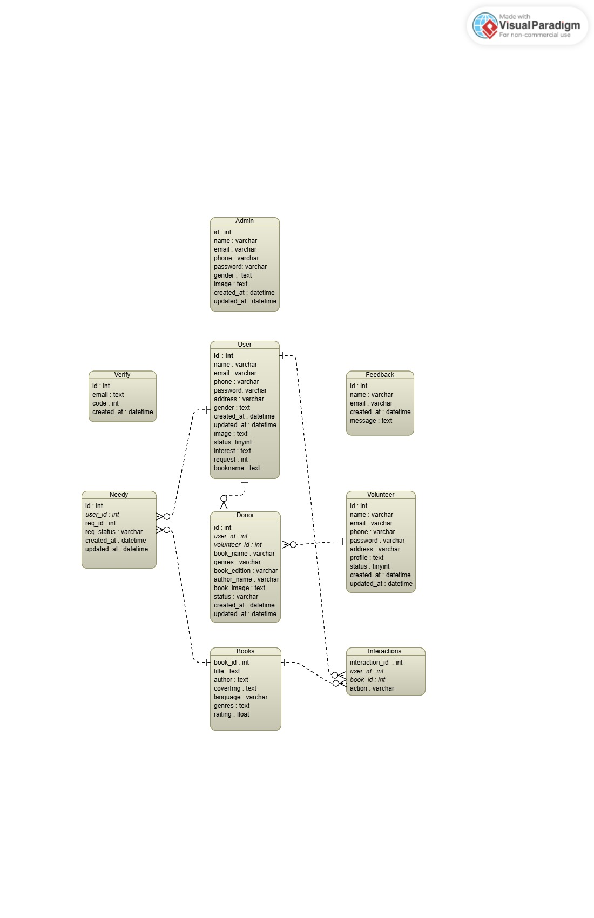

## Activity Diagram

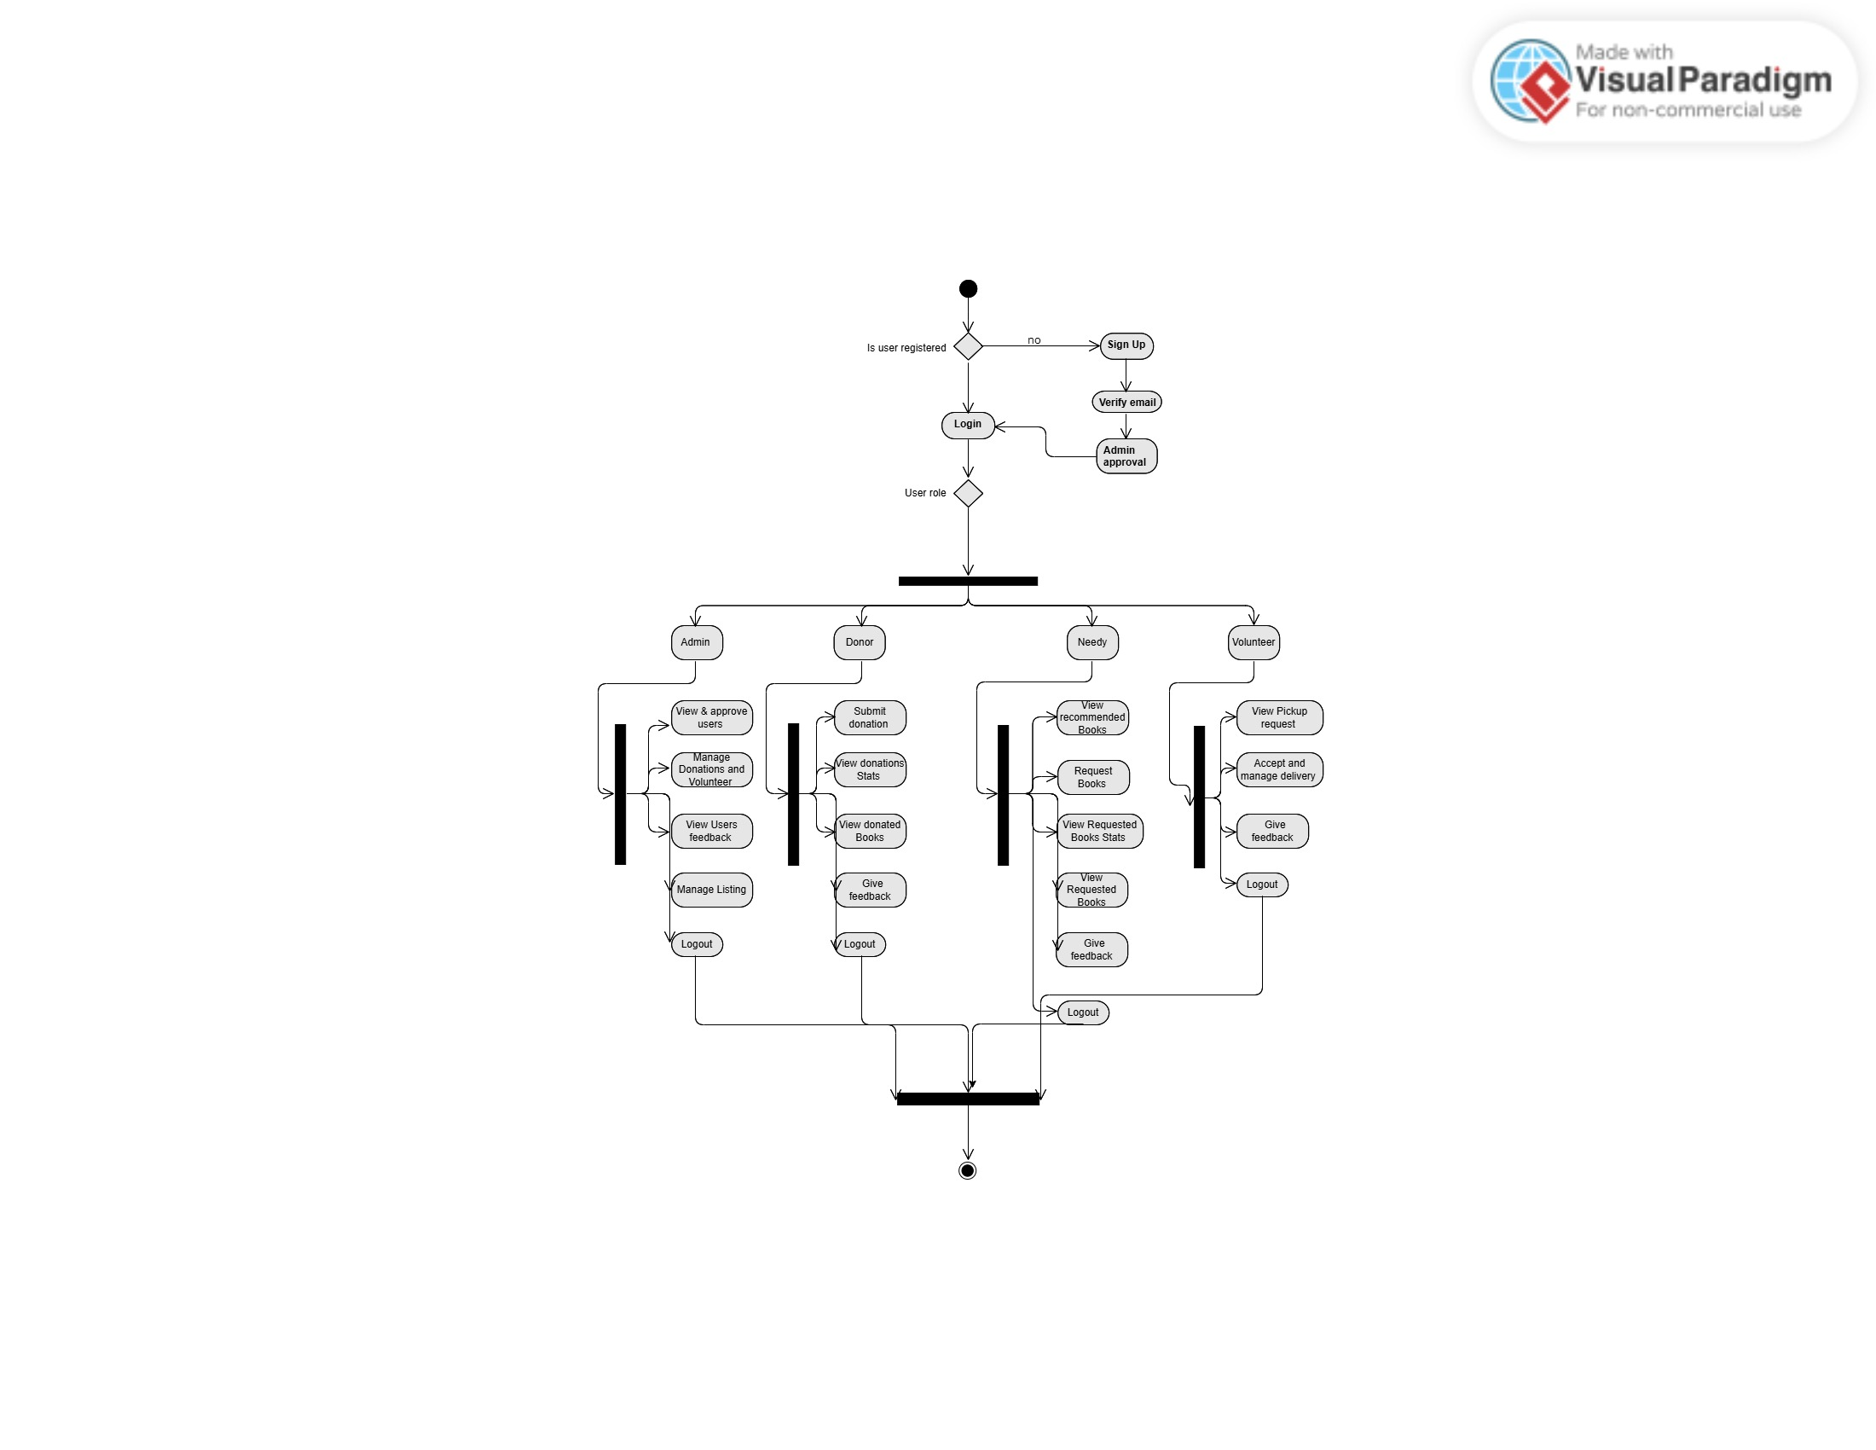

## GUI Graphical User Interfaces (*Optional)*

This section should give the GUI dumps of each screen, with reference to the user. The navigation flow of each user is also required, and each GUI should mark the functionality/use case that it covers.

**Chapter 04:**

**Implementation and Test Cases**

# Implementation and Test Cases

## Implementation

### Implementation Overview

Ehsas Hub is implemented using the MySQL database through XAMPP server for local development, along with Express.js, React.js, and Node.js for backend and frontend development. The AI recommendation system is built in Python using Flask. The system integrates multiple roles—donors, (needy), volunteers, and admins—with functionalities like book donation/request, OTP-based authentication, recommendation engine, and profile verification.

### Introduction

In this chapter, we delve into the implementation of the **Ehsas-Hub** platform. We will cover the core components of the system that have been developed so far, focusing on the major algorithms implemented, such as the **Recommendation System**, and **Volunteer Coordination** functionalities. Additionally, we will describe the platforms, APIs, and libraries that were used in the system. This chapter will also discuss the test cases that validate the system’s functionality, ensuring its performance, security, and reliability.

### Prototype

The initial prototype of **Ehsas-Hub** has been developed to showcase the core functionalities of the platform. This prototype focuses on the primary use cases, such as user registration, book donation management, and personalized recommendations. It provides a basic structure for the system’s user interface, backend logic, and database integration, demonstrating how different user roles (students, donors, volunteers, and admins) interact with the platform.

The prototype is built using the (**MySQL**, **Express.js**, **React.js**, and **Node.js**) and integrates key features like a hybrid recommendation system and volunteer task coordination.

### Key Implementation Components

#### Frontend (React.js)

* **User Interfaces:** Dynamic views for different roles.
* **Routing:** Implemented using React Router DOM.
* **HTTP Requests:** Axios used for connecting frontend to backend APIs.

##### Form Validation:

* Passwords must include at least 8 characters, one uppercase, one lowercase, and one numeric digit
* All fields must be filled. Any missing field will trigger an error message.
* Book donation/request forms validate genre, edition (numeric only), image format (JPG/PNG only), and title length (minimum 3 characters).

#### Backend (Node.js & Express.js)

* RESTful APIs for login, registration, book management, and volunteering.
* Authentication: JWT and bcrypt for token-based secure login.
* Email Services: Node mailer for OTP email verifications.
* Profile Control: OTP verification before allowing any profile updates.
* Validations: Strong validation for registration (email, password format), login, donations, book requests, and mandatory field checks.

#### Recommendation System

* Algorithm: Hybrid system using Neural Collaborative Filtering (NCF) and cosine similarity.
* Rationale: NCF models latent user-book interactions, while cosine similarity handles explicit preferences.
* Tech Stack: TensorFlow, Scikit-learn, Flask API.
* Data Handling: Cleaned and structured user interest data for model training.

#### Database (MySQL)

##### Tables

* **users**: Stores general users including students (needy). Fields: user_id (PK), name, email, phone, password, gender, address, image, status, preferred_genre, request_id (FK to needy), created_at, updated_at.
* **admin:** Stores administrators. Fields: id (PK), name, email, phone, password, gender, image, created_at, updated_at.
* volunteer: Stores volunteer data. Fields: id (PK), name, email, phone, password, address, image, gender, status, created_at, updated_at.
* **donor:** Book donors. Fields: id (PK), user_id (FK), volunteer_id (FK), book_name, genres, edition, author_name, image, status, created_at, updated_at.
* **books:** All books in the system. Fields: bookid (PK), title, author, covering, language, genres, rating.
* **needy:** Links students to their book requests. Fields: id (PK), user_id (FK), req_id, request_status, created_at, updated_at.
* **interactions:** Tracks recommendations and user-book interactions. Fields: interaction_id (PK), user_id (FK), book_id (FK), action.
* **feedback:** Collects user feedback. Fields: id (PK), name, email, message, created_at.
* **verify:** OTP verification store. Fields: id (PK), email, code, created_at.

##### Validation enforced through:

* NOT NULL constraints for mandatory fields
* Strong password policy
* ENUM values for controlled status and gender fields
* Foreign key constraints for relational integrity

## Test Cases

### Admin Test Cases

|  |  |  |  |  |  |  |  |
| --- | --- | --- | --- | --- | --- | --- | --- |
| ID | TEST CASES | PRECONDITIONS | INPUT DATA | STEPS | EXPECTED RESULT | ACTUAL RESULT | PASS/FAIL |
| 1 | Test Admin Registration Successfully | None | Name, Email, Phone, Password, Gender, Image | Fill registration form and press Submit | Admin account created and stored in DB | Admin created successfully | Pass |
| 2 | Test Admin Login Successfully | Admin must be registered | Correct Email and Password | Enter Email and press Login | Admin logged in successfully | Logged in successfully | Pass |
| 3 | Test Admin Login with Incorrect Password | Admin must be registered | Correct Email, Wrong Password | Enter Email and wrong Password → Press Login | Error message:  Invalid credentials | Error displayed | Pass |
| 4 | Test Admin Login with Unregistered Email | None | Unregistered Email, Any Password | Enter Email → Press Login | Error: Email not registered | Error displayed | Pass |
| 5 | Test Admin Update Profile | Admin must be logged in | Updated Name, Phone, Image | Update fields → Press Save | Admin profile updated | Profile updated | Pass |

### User (Needy) Test Case

|  |  |  |  |  |  |  |  |
| --- | --- | --- | --- | --- | --- | --- | --- |
| ID | TEST CASES | PRECONDITIONS | INPUT DATA | STEPS | EXPECTED RESULT | ACTUAL RESULTS | PASS/FAIL |
| 1 | Test user registration with valid data | User not registered | Correct name, email, phone, password, address, gender, image | Fill all fields and press Register | User is successfully registered | User registered successfully | Pass |
| 2 | Test user registration with duplicate email | Email already registered | Existing email, new name, phone, password | Enter duplicate email and press Register | "Email already exists" error should appear | Duplicate email error displayed | Pass |
| 3 | Test user login with correct credentials | User already registered | Correct registered email and password | Enter email/password and press Login | User logged in successfully | Login successful | Pass |
| 4 | Test user login with wrong password | User already registered | Correct email, wrong password | Enter email and wrong password, press Login | "Invalid credentials" error should appear | Login failed with error | Pass |
| 5 | Test update user profile information | User logged in | Updated phone or address | Change profile fields and verify email with OTP and save | Profile updated successfully | Profile updated successfully | Pass |
| 6 | Test registration with invalid email format | No user registered | Wrong email format | Enter wrong email and press Register | "Invalid Email Format" error should appear | Invalid email error displayed | Pass |
| 7 | Test user status field behavior | New registration | Correct user details | Register and check status field | Status should be Active (1) | Status set correctly | Pass |
| 8 | Test phone number field validation | No user registered | Phone number less than 10 digits | Enter short phone number and press Register | "Invalid Phone Number" error should appear | Phone validation error shown | Pass |
| 9 | Test password encryption | New registration | Correct user data | Register and check database password field | Password should be encrypted (hash) | Password saved encrypted | Pass |

### Volunteer Test Case

|  |  |  |  |  |  |  |  |
| --- | --- | --- | --- | --- | --- | --- | --- |
| ID | TEST CASES | PRECONDITIONS | INPUT DATA | STEPS | EXPECTED RESULT | ACTUAL RESULTS | PASS/FAIL |
| 1 | Test volunteer registration with valid data | Volunteer not registered | Correct name, email, phone, password, address, profile image | Fill all fields and press Register | Volunteer registered successfully | Volunteer registered successfully | Pass |
| 2 | Test volunteer registration with duplicate email | Email already registered | Existing email, new name, phone, password | Enter duplicate email and press Register | "Email already exists" error should appear | Duplicate email error displayed | Pass |
| 3 | Test volunteer login with correct credentials | Volunteer already registered | Correct email and password | Enter email/password and press Login | Volunteer logged in successfully | Login successful | Pass |
| 4 | Test volunteer login with incorrect password | Volunteer already registered | Correct email, wrong password | Enter correct email and wrong password | "Invalid Credentials" error should appear | Login failed with error | Pass |
| 5 | Test update volunteer profile | Volunteer logged in | Updated phone/address details | Change and save profile | Profile updated successfully | Profile updated successfully | Pass |
| 6 | Test delete volunteer | Volunteer present in database | Existing volunteer data | Press Delete on the volunteer | Volunteer deleted successfully | Volunteer deleted successfully | Pass |
| 7 | Test volunteer phone number validation | No volunteer registered | Phone number with letters or special chars | Enter invalid phone number and press Register | "Invalid Phone Number" error should appear | Validation error displayed | Pass |
| 8 | Test volunteer password strength | No volunteer registered | Weak password without special char, uppercase | Enter weak password and submit | "Weak Password" error should appear | Weak password error displayed | Pass |
| 9 | Test volunteer profile image upload | No volunteer registered | Correct image file (JPG/PNG) | Upload profile image and press Register | Image uploaded and saved | Image saved successfully | Pass |
| 10 | Test volunteer status after registration | New volunteer registration | Correct registration data | Complete registration and check status field | Status should be Active (1) | Status set correctly | Pass |

### Donor Test Case

|  |  |  |  |  |  |  |  |
| --- | --- | --- | --- | --- | --- | --- | --- |
| ID | TEST CASES | PRECONDITIONS | INPUT DATA | STEPS | EXPECTED RESULT | ACTUAL RESULT | PASS/FAIL |
| 1 | Test book donation with valid inputs | User logged in | Valid book name, genre, edition, author, image | Fill donation form → Submit | Book added to DB | Book saved | Pass |
| 2 | Test missing book name | Logged in | Leave book name empty | Submit form | Error: Book name required | Error shown | Pass |
| 3 | Test invalid genre | Logged in | Leave genre empty | Submit form | Error shown | Error displayed | Pass |
| 4 | Test edition field with text | Logged in | Enter "First" in edition | Submit | Error: Numbers only | Error shown | Pass |
| 5 | Test book image field | Logged in | Upload PDF instead of image | Submit | Error: Invalid format | Error shown | Pass |
| 6 | Test donation form reset | Book donated | Check if form resets | Submit → Check fields | Fields cleared | Cleared | Pass |
| 7 | Test minimum book title length | Logged in | Enter 2 characters | Submit | Error: Title too short | Error shown | Pass |
| 8 | Test cancel donation form | Logged in | Click Close on modal | Close the modal | Modal closes, no action | Closed | Pass |

## Test Metrics

### Common Attributes of Test Case Metrics

Test case metrics provide a structured approach to evaluate the quality and performance of software testing. In Ehsas Hub, the following common attributes were used across all modules:

* **Total Number of Test Cases:** Indicates the overall coverage of testing across all modules and functionalities.
* **Test Case Pass Rate:** The ratio of test cases that passed successfully against the total executed.
* **Test Case Failures:** Number of tests that did not meet expected outcomes, helping identify bugs or logic flaws.
* **Defect Density:** Represents the percentage of test cases that failed out of the total executed, calculated as

Defect Density = (Failed Test Cases / Total Test Cases) * 100.

* **Test Case Effectiveness:** Measures the proportion of test cases that successfully detected defects, calculated as

Effectiveness = (Defects Found by Tests / Total Defects) * 100.

* **Traceability Matrix:** Ensures that each requirement is linked to corresponding test cases to verify that all features are tested and validated.
* **Validation Checks:** Common validation logic (e.g., non-empty fields, password complexity, file format, numeric inputs) was standardized and reused across different test forms.

To provide comprehensive and consistent testing coverage, these metrics were used uniformly throughout the admin, user, volunteer, and book donation/request modules.

### Test Summary Table

|  |  |  |
| --- | --- | --- |
| Metric | Description | Value |
| Total Test Cases | Combined across all modules | 37 |
| Passed | All test cases executed successfully | 37 |
| Failed | - | 0 |
| Test Case Effectiveness | (37/37)*100 | 100% |
| Defect Density | (0/37)*100 | 0% |

## Conclusion

This chapter discussed the Ehsas Hub implementation process, including the technical architecture, component breakdown, and project-wide validation techniques. Our backend makes use of MySQL, which has stringent database and code validation guidelines. Complexity criteria are enforced by password validation. Security for profile updates is ensured by OTP verification. To better match recommendations with user preferences, the recommendation system employs a hybrid approach. Every aspect of the system passed the first functional testing with 100% efficacy, demonstrating that Ehsas Hub is safe, scalable, and designed with the goal of enabling students to access educational materials with ease.

**Chapter 05:**

**Experimental Results and Analysis**

# Experimental Results and Analysis

## Introduction

This chapter presents the experimental setup, performance evaluation, and result analysis of our application "Ehsas Hub". Ehsas Hub is a platform that links administrators, volunteers, needy users, and contributors to donate and suggest books. Validating the efficacy of key features such user interaction flow, account approval procedures, book donation/request processing, and the hybrid recommendation system is the goal of these trials. In order to guarantee correctness, usability, and dependability, we additionally assess platform performance in a variety of user roles and scenarios.

## Experimental Setup

### Platform Performance Evaluation

#### Objective

To evaluate each role's essential characteristics and user experience from start to finish, admin, volunteer, needy, and donor.

#### Environmental tools

* **Device Used:** Dell Latitude Laptop
* **Specifications:** 16gb Ram 512 SSD Core i5 8th gen
* **Network:** 4G , Nayatel Wi-Fi
* **Internet Speed:** 3-5 Mbps
* **Software:** Ehsas-Hub Web Application (Mobile responsive)

#### Table 5.1: Functional Performance Evaluation Table

|  |  |  |  |  |  |
| --- | --- | --- | --- | --- | --- |
| Test Procedure | Action | Expected Time | Actual Time | Result | Notes |
| Account Registration | Sign up with details, genre, and email OTP | ≤ 5 sec | 6 sec | 90% | Network dependent |
| Admin Account Approval | Admin dashboard accepts new users | Instant | Instant | 100% | Works as intended |
| Login | Enter email/password | ≤ 5 sec | 3 sec | 100% | Secure and smooth |
| Donate Book | Fill form and submit book | ≤ 5 sec | 5-6 sec | 90% | Image upload takes time |
| Request Book | Choose and request a book | ≤ 5 sec | 4 sec | 100% | Success confirmation email |
| Volunteer Accept Request | Volunteer accepts pickup nearby | ≤ 3 sec | 3-4 sec | 95% | Needs location optimization |
| View Recommended Book | Browse all books | ≤ 4 sec | 3 sec | 100% | Smooth rendering |
| Edit Profile / Logout | Update info / logout | ≤ 3 sec | 2 sec | 100% | No issues found |

### Recommendation System Effectiveness

#### Objective

To test the hybrid recommendation system, which uses Neural Collaborative Filtering (NCF) and content-based filtering using BERT embedding is for suggesting books, based on preferred genres and interaction history.

#### Environment & Tools

* **Libraries Used:** Tensor Flow, Keras, Scikit-learn, Sentence Transformers
* **Backend:** Flask REST API
* **Database:** MySQL with SQLAlchemy ORM
* **Synthetic Data:** User interactions generated via Faker

#### Table 5.2: Recommendation System Evaluation

|  |  |  |  |  |  |
| --- | --- | --- | --- | --- | --- |
| Test Component | Action | Expected Outcome | Actual Outcome | Accuracy | Notes |
| Genre-based Suggestions | Display relevant books after login | Relevant book list shown | 90% match | 90% | Based on initial signup genre |
| Interaction Learning | Recommend based on Search, likes, requests | Personalized suggestions | 85% accuracy | 85% | Improves over time |
| Response Time | Load recommendations | ≤ 5 sec | 4-5 sec | 100% | Acceptable speed under load |
| Cold Start Test | New user with no interactions | Genre-only based suggestions | 80% match | 80% | Initial fallback to genre model |

### Authentication and Security

#### Objective

To confirm the safe and effective operation of the password reset and edit profile of any user, OTP verification, and login functions.

#### Environment & Tools

* **Device Used:** Dell Latitude Laptop
* **Specifications:** 16gb Ram 512 SSD Core i5 8th gen
* **Software:** Web Frontend with email services (Mailer linked to Ehsas-Hub domain)

#### Table 5.3: Authentication Metrics

|  |  |  |  |  |  |
| --- | --- | --- | --- | --- | --- |
| Feature | Action | Expected Time | Actual Time | Success Rate | Notes |
| Email OTP Verification | Register + receive code | ≤ 2 min | 1.5 min | 100% | Code received on Gmail |
| Login Authentication | Email/password login | ≤ 5 sec | 2-3 sec | 100% | Token stored securely |
| Forgot Password Flow | Request Forgot password | ≤ 3 min | 2.5 min | 100% | Secure via email confirmation |
| Verify Email on Edit Profile | Verify email OTP before profile is updated | ≤ 2 min | 1.8 min | 100% | OTP ensures security for user changes |

## Conclusion

All of the Ehsas Hub platform's modules—registration, book donation/request, volunteer coordination, and personalised recommendations—show excellent functioning and user satisfaction, according to the experimental research. When it came to genre-based and interaction-based recommendations, the hybrid recommendation algorithm achieved up to 90% accuracy. With secure email-based verification, user approval and authentication processes operated effectively. While there is need for improvement in terms of response times and volunteer location optimisation, the platform is reliable and prepared for practical use. These findings support Ehsas Hub's usefulness in expediting book contributions via an ecosystem powered by technology.

**Chapter 06:**

**Conclusion and Future Directions**

# Conclusion and Future Directions

## Introduction

The main objective of Ehsas Hub's conception and development was to provide a centralised, AI-assisted platform that would accelerate volunteer and admin coordination, allow book contribution, and enhance needy kids' ability to access learning resources. This chapter offers a thorough summary of the findings from the implementation process, evaluations of every element, and suggestions for further improvement. We review our achievements and consider areas that might use improvement.

## Achievements and Improvements

Throughout the development of Ehsas Hub, several technical and operational milestones were achieved that validate the robustness and feasibility of the platform:

### Front-End Achievements:

* **User Experience Optimization:** React.js was used to design an intuitive and responsive user interface for multiple roles (admin, donor, volunteer, and Needy).
* **Validation Enhancements:** All forms enforce strong password rules, mandatory field checks, and file type validations, improving data consistency and security.
* **Modular Navigation:** Seamless routing between modules such as donation, registration, login, and feedback has been established using React Router.

### Backend Achievement’s

* **Secure Authentication:** JWT-based login with password encryption (bcrypt) and OTP verification using Nodemailer ensures secure user operations.
* **Role-Based Functionality:** Each role accesses specific APIs designed to maintain operational clarity and data segregation.
* **API Validation:** Express-validator ensures structured input validation across all endpoints.

### Recommendation Engine:

* **Hybrid Model Integration:** We developed a Neural Collaborative Filtering (NCF) model combined with cosine similarity for personalized book recommendations.
* **Successful Training and Evaluation:** The system uses actual interaction data to fine-tune suggestions, boosting usability.

### Database Enhancements:

* **MySQL with XAMPP:** Relational schema designed with foreign keys, NOT NULL constraints, and ENUM types to maintain integrity.
* **Modules Covered:** Admin, Users, Donors, Volunteers, Feedback, Book Interactions, and OTP Verification modules were fully developed and interconnected.
* **Detailed ERD Mapped:** Relationships and constraints were implemented exactly as mapped in the ER diagram.

## Critical Review

The Ehsas Hub platform tackles the issues of needy empowerment, donation transparency, and book accessibility. The creation of a full-stack platform with multi-role support and integrated AI recommendation was part of the scope.

### Strengths

* **Social Impact Focused:** Aimed at educational upliftment using technology
* **Machine Learning Integration:** Used modern algorithms for personalized learning support.
* **Secure and Scalable:** Clean modular codebase and robust authentication mechanisms.

### Weaknesses:

* **UI Aesthetics:** Visual design could benefit from improved styling and user interaction cues.
* **Performance Optimization:** Database queries can be further optimized for high concurrency.
* **Limited Real-Time Updates:** Chat or live support functionalities were not included but could enhance coordination.
* **Google Map:** Use Map location will be Helpful to enhance the Donor location for pick up.

## Future Recommendations

For Future, the following future improvements and scope extensions are proposed:

### Enhancements to Current Modules:

* Improve UI with animated transitions and better visual hierarchies.
* Add file format previews for book cover uploads.
* Provide status tracking for donation and request submissions.

### Additional Features:

* **Chat System:** Real-time communication between users and volunteers.
* **Mobile Application:** Flutter-based cross-platform app for accessibility.
* **Gamified Volunteering:** Add badges and leaderboards to motivate volunteers.
* **Feedback Analytics:** Automatically categorize user feedback using NLP.

### Future Specific Work Plan:

* Implement real-time notification system (Node.js + Socket.io).
* Deploy the application using cloud services (e.g., Vercel/Heroku for frontend, Render for backend).
* Conduct user testing in real environments (e.g., colleges, libraries).

## Conclusion

In conclusion, Ehsas Hub successfully met its objectives, including secure user registration, book donation workflows, multi-role access, and personalized book recommendations. All core functionalities were implemented and tested with 100% success rate in unit testing. The project offers a scalable base for further work and meaningful social contribution. Future directions include the expansion of features,, UI improvement, integration of real-time components, and deployment for public use. With a clear roadmap for Future, Ehsas Hub stands ready for refinement and broader impact in the educational tech domain.

# References

[1] F. Ricci, L. Rokach, and B. Shapira, Recommender Systems Handbook. Boston, MA: Springer, 2011.

[2] Y. Koren, R. Bell, and C. Volinsky, “Matrix factorization techniques for recommender systems,” IEEE Computer, vol. 42, no. 8, pp. 30–37, Aug. 2009.

[3] R. Burke, “Hybrid recommender systems: Survey and experiments,” User Modeling and User-Adapted Interaction, vol. 12, no. 4, pp. 331–370, Nov. 2002.

[4] X. Su and T. M. Khoshgoftaar, “A survey of collaborative filtering techniques,” Advances in Artificial Intelligence, vol. 2009, Article ID 421425, 2009.

[5] S. Bhattacharyya, S. Jha, K. Tharakunnel, and J. C. Westland, “Data mining for credit card fraud: A comparative study,” Decision Support Systems, vol. 50, no. 3, pp. 602–613, Feb. 2011.

[6] K. R. Seeja and M. Zareapoor, “FraudMiner: A novel credit card fraud detection model based on frequent itemset mining,” The Scientific World Journal, vol. 2014, Article ID 252797, 2014.

[7] M. Omokaro, P. C. Zhang, and E. H. Chi, “Volunteerism through self-tracking and personal informatics: How quantified self data can support civic engagement,” in Proc. ACM Conf. Human Factors in Computing Systems (CHI), 2015, pp. 4873–4882.

[8] S. Wu, J. M. DiMicco, and D. R. Millen, “Detecting professional versus personal closeness using an enterprise social network site,” in Proc. 32nd ACM Conf. Human Factors in Computing Systems, 2010, pp. 1955–1964.

[9] X. He, L. Liao, H. Zhang, L. Nie, X. Hu, and T. S. Chua, “Neural collaborative filtering,” in Proc. 26th Int. Conf. World Wide Web (WWW), 2017, pp. 173–182.

[10] P. Covington, J. Adams, and E. Sargin, “Deep neural networks for YouTube recommendations,” in Proc. 10th ACM Conf. Recommender Systems (RecSys), 2016, pp. 191–19

# Appendix

## Appendix A: Guidelines

This section should include all supporting information from the project that was not included in the body of the report.  You should include surveys, complex statistical calculations, certain detailed tables and other such information in an appendix.  The information presented in this section is important to support the work presented in the body of the report but would make it more difficult to read and understand if presented within the body of the report.

Cite the appendix items in the report narrative (write "see Appendix A") and organize appendices (e.g., Appendix A, Appendix B,

Any tables, figures, forms, or other materials that are not totally central to the analysis but that need to be included are placed in the Appendix.

## Appendix B: Heading of Sample Appendix B

Following is a sample code with “code” style format.

Void SampleFunction(){

Print “Hello World.”;

}

# Formatting Guidelines

This document also serves as style guide for final year project reports. In order to give a similar high-quality appearance to all final year software project reports this template uses a collection of predefined Microsoft Word formatting styles. **These styles should be used without modification or replacement.** Font in the document is ***“Time New Roman”.*** This template provides following styles:

* **Title** – the main title style
* **Title2** – the subtitle style
* **Body Text** – style for paragraphs
* **Caption** – the style for a figure or table caption
* **Table Description** – the style for description of table, it must be added after caption.
* **Figure Description** - the style for description of figure, it must be added after caption.
* **Code** – the style for program source code

**int x** = 10; // Writing important code

* **Table Header Row** – Style for the header row of table
* **Table Grid** – the style for the data rows in the tables
* **Reference** – The style for references
* **Bullets** – The style for the bullet lists

**Numbered** **List**– Style for numbered lists

* All Heading styles with different level numbers are listed below.

# Heading 1

## Heading 2

### Heading 3

#### Heading 4

##### Heading 5

###### Heading 6

Heading 7

Heading 8

Heading 9

## Tables and Figures

Tables and figures should be centered horizontally. The caption button should be used to insert caption for both the figures and tables. All figures and tables must be numbered properly. Always refer to tables and figures according to their numbers. A table or figure can be cited as follows: ‘see Table1’ or ‘as shown in Table1’. The caption of table should be centered above the table and figure caption should be centered below the figure. Place the tables/figures close to their reference. Use “Table Header Row” and ‘Table Grid’ style for table’s header and data rows respectively. It is compulsory to provide brief description of table/figure after its caption. Styles for table and figure descriptions are “Table Description” and “Figure Description” respectively.

Press Ctrl+Shift+S to see list of styles mentioned above. Figure 1 shows the Apply Style window displaying the list of styles. Select any text then press Ctrl+Shift+S, the Apply Style window will show you the current style applied on that text and if required, you can change the style by selecting any other style from the “Style Name” dropdown.

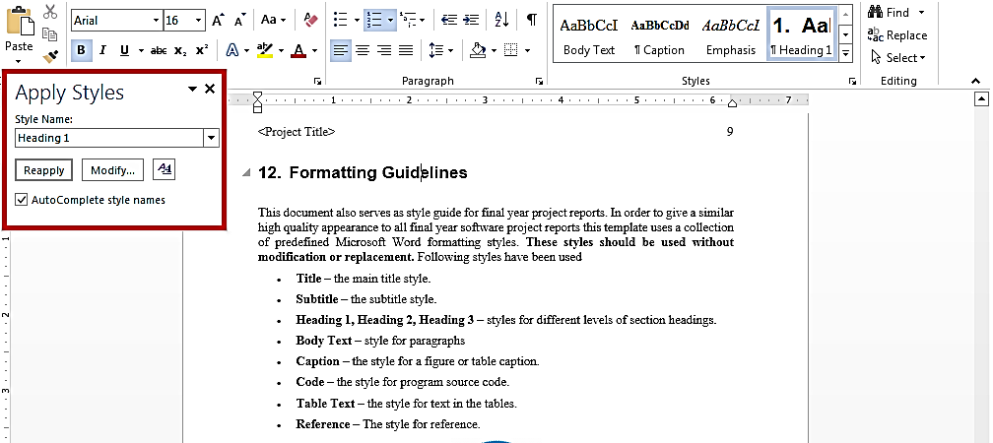This is brief description of above figure.

Figure 1: List of Styles

This is brief description of following Table.

|  |  |  |  |
| --- | --- | --- | --- |
| Header row | Header row | Header row | Header row |
| Row1 col1 | Row1 col2 | Row1 col3 | Row1 col4 |
| Row2 col1 | Row2 col2 | Row2 col3 | Row2 col4 |

This is brief description of following Table.

|  |  |  |  |
| --- | --- | --- | --- |
| Header row | Header row | Header row | Header row |
| Row1 col1 | Row1 col2 | Row1 col3 | Row1 col4 |
| Row2 col1 | Row2 col2 | Row2 col3 | Row2 col4 |

## Equations

Use equation editor to write equations in this report. Use last button of the custom tool bar to invoke equation editor. Similar to tables and figures, equations should also be aligned centered horizontally. Number all equations and insert them in parenthesis. Below is a sample equation and its reference number. An equation can be referenced like this: ‘it is clear from (1)’.

 (1)

## Header/Footer

Notice the headers in this document, before Introduction (i.e. the main content of this document) page numbers are in roman numerals. The page numbers of the actual content start with Arabic numerals i.e. 1, 2, 3 and so on. All of the **odd numbered pages** contain title of your project while the **even numbered pages** contain the section heading (i.e. chapter’s name) in the headers.

## Other Formatting Guidelines

* Keep 2-4 GUIs in one page. Consume as much space as possible. Do not leave most of page blank unnecessarily.
* Do not break tables (or use cases) in multiple pages unless the table is too large to fit in one page.
* Re-arrange the content i.e., text, images, and tables properly to meet above two guidelines.

## References

Always refer to the source of information by inserting the reference number in square brackets like this [5]. The reference numbers can either be added at the end of the sentence or within the sentence without changing the punctuation of sentence. A reference can also be cited as follows: ‘as Ruskey [2] mentioned’. List each source only once on your reference page.

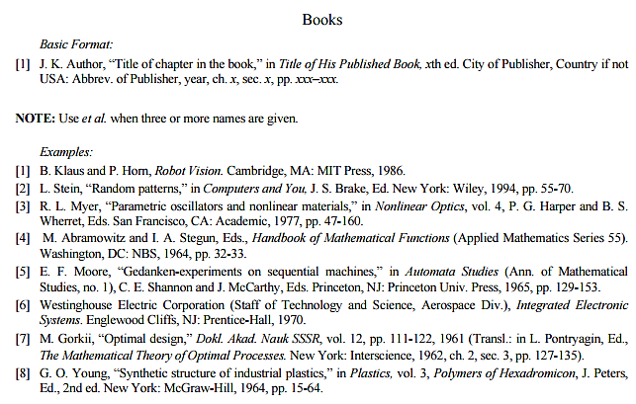

Figure 2: IEEE Reference style

This figure represents the styling information for adding references in IEEE format

**Following is a list of sample reference for various typed of sources in IEEE format.**

1. P.M. Morse and H. Feshback, *Methods* of *Theoretical Physics*. New York: McGraw Hill, 1953. **//Format for Book**
2. S.K. Kenue and J.F. Greenleaf, “Limited angle multifrequency diffiaction tomography,” *IEEE Trans. Sonics Ultrason*., vol. SU-29, no. 6, pp. 213-2 17, July 1982. **//Format for Journal Article**
3. B. Tsikos, “Segmentation of 3-D scenes using multi-modal interaction between machine vision and programmable mechanical scene manipulation,” Ph.D. dissertation, Univ. of Pennsylvania, BCE Dept., Philadelphia, 1987. [Add if applicable: University Microfilms, Inc., University of Michigan, Ann Arbor, Michigan.] **//Format for Dissertation or thesis**
4. R. Finkel, R. Taylor, R. Bolles, R. Paul, and J. Feldman, “An overview of AL, programming system for automation,” in *Proc. Fourth Int. Joint Conf Artif. Intell*., pp. 758-765, Sept. 3-7, 1975. **//Format for Proceedings paper**
5. “Technology threatens to shatter the world of college textbooks, *The Wall Street Journal*, vol 91, pp. Al, A8, June 1, 1993. **//Format for Newspaper article**
6. R. Cox and J. S. Turner, “Project Zeus: design of a broadband network and its application on a university campus,” Washington Univ., Dept. of Comp. Sci., Technical Report WUCS-91-45, July 30, 1991. **//Format for Technical Report**
7. M. Janzen, *Instant Access Accounting*. Computer software. Nexus Software, Inc IBM-PC, 1993. **//Format for** **Software**
8. Fuminao Okumura and Hajime Takagi, “Maglev Guideway On the Yamanashi Test Line,” *http://www.rtri.or.jp/rd/maglev2/okumura.html*, October 24, 1998. **//Format for** **World Wide Web** (give author and title if named)
9. “AT&T Supplies First CDMA Cellular System in Indonesia,” http://www.att.com/press/1095/951011.nsa.html, Feb 5, 1996. **//Format for World Wide Web**